**Biology: 9. The Circulation System**

***Please remember to photocopy 4 pages onto one sheet by going A3→A4 and using back to back on the photocopier***

**Syllabus**

**OB13** Describe the function and composition of blood (white blood cells, red blood cells and platelets in a liquid called plasma) and state the function of each component .

**OB14** State the function of the heart; describe its structure, identifying the four chambers; explain the difference between the left and the right ventricle

**OB15** Describe the passage of blood through the heart and lungs via arteries and veins, identify the pulmonary artery and vein, aorta and vena cava, and distinguish between arteries, veins and capillaries

**OB16** Demonstrate the effect of exercise and rest on pulse and breathing rate and appreciate that a balance of each promotes good health

**OB17** Recall that the average pulse rate for an adult at rest is 70 b.p.m., and explain why exercise results in increased pulse and breathing rates

**OB18** Recall that the normal temperature of the human body is 37 °C, and that illness may cause a change in body temperature

**OB19** Associate the circulation of the products of digestion around the body with their absorbtion into the bloodstream

**Student Notes**

**The circulatory system consists of blood, the heart and blood vessels**

**Blood: composition and function of blood**

**Oxygen and food are absorbed into the bloodstream and are circulated around the body, to be distributed to each cell in the body as required.**



|  |  |
| --- | --- |
| **Part** | **Function** |
| Plasma | Liquid part of blood.  Carries blood cells, digested food and wastes around the body |
| Red blood cells | Contains haemoglobin (iron-based pigment) which carries the oxygen  (5 million per mm3) |
| White blood cells | Fight infection – engulf germs or release antibodies which kill germs. |
| Platelets | Blood clotting |

**Red Blood Cell on a microscope**

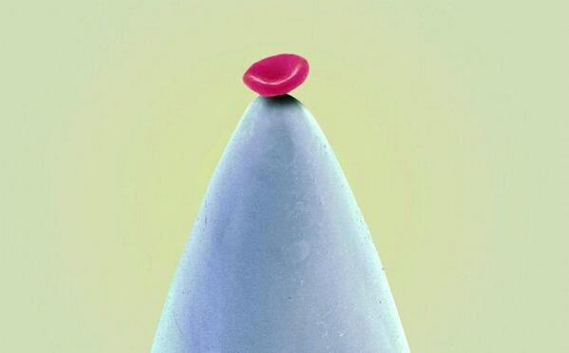**The Heart**

The heart pumps blood around the body

**There are four chambers in the heart**

The four chambers of the heart consist of the **right atrium**, the **left atrium** the **right ventricle**, and the **left ventricle**.

**The 'DOUBLE' pump of the Human Heart**

**Passage of blood through the heart and lungs via arteries and veins**

(Syllabus: identify the pulmonary artery, pulmonary vein, aorta and vena cava)

Body → vena cava → right atrium → valves → right ventricle → pulmonary artery → lungs → pulmonary vein → left atrium → left ventricle → aorta → body

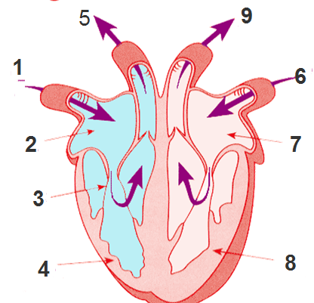

1. Deoxygenated blood FROM THE BODY entering the heart (via the **VENA CAVA**).
2. The RIGHT ATRIUM .
3. The VALVES prevent blood flowing the wrong way when the atria and ventricles contract.
4. The RIGHT VENTRICLE.
5. Deoxygenated blood leaving the heart and flowing TO THE LUNGS (via the **PULMONARY ARTERY**).
6. Oxygenated blood FROM THE LUNGS entering the heart (via the **PULMONARY VEIN**).
7. The LEFT ATRIUM.
8. The thicker walled LEFT VENTRICLE.
9. Oxygenated blood leaving the heart and flowing TO THE BODY (via the **AORTA**).

Remember:

1. For both the left and right-hand sides the blood flows through the heart in the following order:

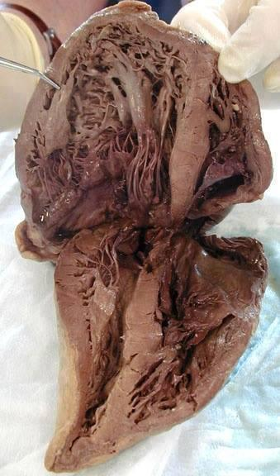Vein → Atrium → Ventricle → Artery    i.e. ***V A V A*** *(voom!)*

1. **A**rteries carry blood **A**way from the heart. (Remember ***AA***).

**The difference between the left and right ventricles**

The left ventricle has thicker walls than the right ventricle because the left ventricle pumps blood all around the body whereas the right ventricle just pumps blood to the lungs.

**The four main blood vessels going into and out of the heart**

|  |  |  |
| --- | --- | --- |
| **Blood vessel** | **Carries blood from:** | **Carries blood to:** |
| Pulmonary artery | Heart | Lungs |
| Pulmonary vein | Lungs | Heart |
| Aorta | Heart | Body |
| Vena cava | Body | Heart |

**Blood vessels: Arteries, veins** **and capillaries**



|  |  |  |
| --- | --- | --- |
| **Arteries** | **Veins** | **Capillaries** |
| Have thick walls to resist pressure | Have thin wall because the pressure is much less. | Have very thin walls one cell thick) to allow substance to pass in and out from cells. |
| Carry blood under high pressure | Carry blood under low pressure |  |
| Cary blood AWAY from heart | Carry blood TO the heart | Connect arteries to veins |
| No valves | Have valves to prevent backflow of blood |  |
| Narrow lumen | Wide lumen |  |
| Blood travels in spurts | Blood flows evenly |  |

**Your pulse**

**The average pulse rate for an adult at rest is 70 beats per minute**

**Exercise results in increased pulse and breathing rates**

**Why?**

The body uses a lot of energy when exercising so the heart needs to pump a lot of oxygen and food around the body. This results in an increase in heart-beat and rate of breathing.



**To demonstrate the effect of exercise and rest on pulse and breathing rate**

A pulse is caused by the surge of blood in an artery due to a heartbeat.

1. Count the number of beats per min at your wrist or at your neck.
2. Exercise vigorously for two minutes.
3. Take your pulse again.

Result: Your pulse rate should now be much greater.

Conclusion: Exercise increase heartbeat and pulse rate.

Exercise is beneficial to the heart as it makes it stronger and reduces weight.

Note: Heart rate can also be increased by excitement, anxiety and smoking.

**A balance of exercise and rest promotes good health**

**The normal temperature of the human body is 37 °C but illness may cause a change in body temperature**

**Did you know?**

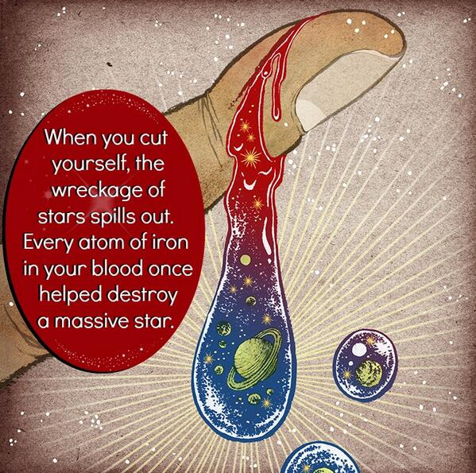

**Did you know: a human could crawl through the heart arteries of a blue whale?**

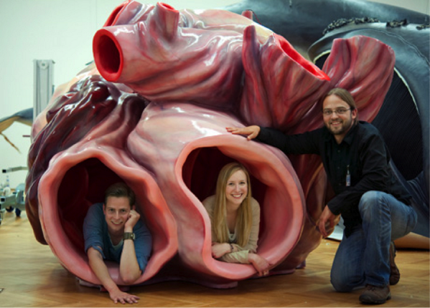

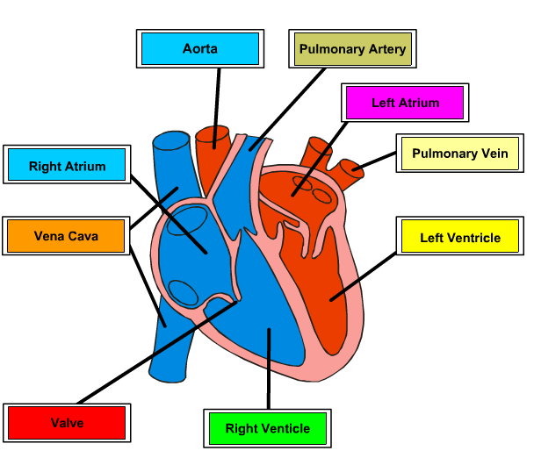**Your Heart**

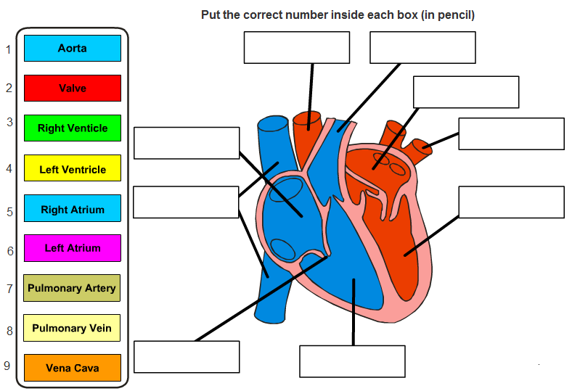

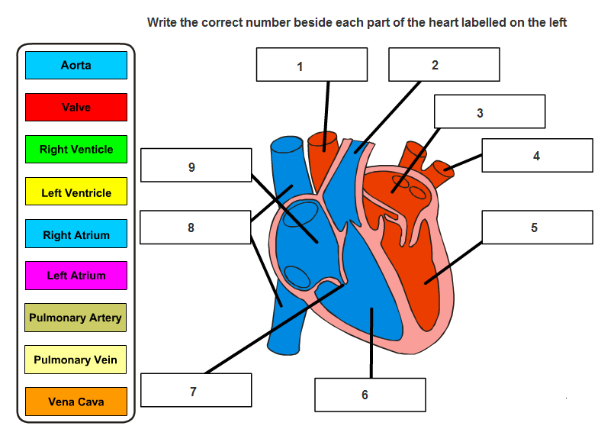

**Exam Questions**

**Blood**

1. [2006] [2008] [2010 OL] [2006 OL][2012 OL]

Blood is a liquid tissue. Name any three components of blood.

Give the function of each of the components of blood you have named.

1. [2012]
2. Why is blood considered to be a tissue?
3. Name a substance transported by blood.

**The Heart**

1. [2009 OL][2007 OL][2006][2012 OL]

Why is the wall of the left side of the heart thicker than the wall of the right side?

1. [2009 OL]

The heart forms part of the circulatory system.

Answer the following questions on the heart and the circulatory system.

1. The blood vessels labelled A in the diagram carry blood away from the heart.

Name this type of blood vessel.

1. What is the name of the small chamber of the heart labelled B in the diagram?



1. [2006 OL]

Name the chambers of the heart labelled X and Y in the diagram.

1. [2007 OL]

Blood moves through vessels called arteries and veins.

1. What is the name of the blood vessels that carry blood away from the heart?
2. What is the name of the blood vessels that carry blood to the heart?

1. [2009]

Label clearly the pulmonary artery with an A, and the pulmonary vein with a V in the diagram of the heart.



1. [2008]

The diagram shows cross sections of an artery and of a vein. Why do arteries have much thicker walls than veins?

1. [2008]

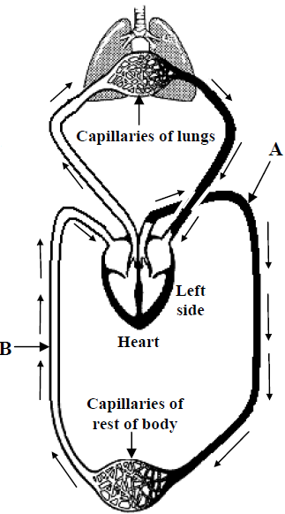Give one other structural difference between arteries and veins.

1. [2011]

The simplified diagram shows the flow of blood through the lungs, heart and rest of the body.

1. Name the blood vessels labeled A and B.
2. Capillaries are small blood vessels.

Describe the two changes in the composition of blood after it has passed through the capillaries of the lungs shown.

1. What feature of capillaries allows these changes to happen?
2. Name the chamber of the heart that pumps blood to the lungs.

**Your Pulse**

1. [2006]

What causes a person’s pulse?

1. [2006]

The diagram shows a person’s pulse rate being taken.

How is a person’s pulse rate measured using this method?

1. [2010 OL][2012 OL]

A person’s pulse is often taken to measure the rate of heart beat.

Normal pulse rate is 70 beats per minute (bpm).

Exercise and rest have an effect on pulse rates.

Answer the following questions about exercise and healthy living.

1. Exercise causes a person’s pulse rate to ________________________.
2. Rest causes a person’s pulse rate to ___________________________.
3. A balance of exercise and rest promotes good health.

Name one other action a person can take to keep their heart healthy.

1. [2006]

An athlete’s resting pulse rate is 58. After 10 minutes strenuous exercise their pulse rate was 120. After resting for 5 minutes their pulse rate reduced to 63. Clearly account for the rise and fall in pulse rate experienced by the athlete.

**Exam Solutions**

1. Platelets - Clot blood

Red corpuscles (cells) - transport oxygen

White corpuscles (cells) - fight infection/ kill germs/ make antibodies

1. It contains cells
2. Oxygen/ carbon dioxide/ food/ name of digested food/ wastes/urea/ ions/ hormones/ water/ minerals/ vitamins/ cholesterol/ …
3. Left side has to pump blood around body / right side pumps only to lungs.
4. Artery
5. Atrium
6. X: Right atrium / auricle

Y: Left ventricle

2. Arteries
3. Veins
4. See diagram
5. The blood is under higher pressure
6. No valves in arteries/ veins have valves

Small lumen in arteries/ large lumen in veins

1. **A:** aorta

**B:** vena cava

1. Carbon dioxide (CO2) removed (less CO2)

oxygen (O2) added (more O2)

water (H2O) vapour removed

1. thin walls/ walls one cell thick
2. right ventricle
3. The heart beating (pumping blood).
4. Count the number of beats per min.
5. Increase
6. Decrease
7. Healthy diet (or qualified example) / no smoking / weight control / avoid stress / regular health checks
8. Rise in pulse rate: need more oxygen (food) (energy)

Fall in pulse rate: need less oxygen (food) (energy)

**Other Test Questions**

1. What is the main function of the heart?
2. What are the four main chambers of the heart?
3. Draw a diagram of the heart. Identify on the diagram the pulmonary artery and vein, aorta and vena cava, and also the four main chambers.
4. Distinguish between arteries, veins and capillaries.
5. Describe how you would demonstrate the effect of exercise and rest on pulse and breathing rate.
6. What is the average pulse rate for an adult at rest?
7. What is the normal temperature of the human body?
8. What is the effect of illness on body temperature?
9. What is the average resting pulse?
10. What is the effect of exercise on your pulse?
11. Why do athletes train at high altitude, thereby increasing the number of red blood cells, to improve their performance?
12. Does a fitter person’s heat rate return to normal quicker or slower?

**Extra Material**

**The functions of the Circulatory System**

1. To carry OXYGEN to all the cells in the body
2. To carry FOOD to all the cells in the body
3. To remove WASTE from the cells of the body
4. To distribute HEAT around the body
5. To form a part of the DEFENCE the body has against microbes
6. To REPAIR itself and prevent blood loss by clotting

**Did You Know?**

1. Each day your body makes 200 billion new blood cells.
2. White blood cells live for two weeks; red blood cells live for four months.
3. You have 60,000 miles of blood vessels
4. You have about 5 litres of blood in your body; when you donate blood you give up about half a litre.
5. Your heart is about the size of an apple.
6. Your heart pumps about 70 times a minute, which equates to over 100,000 times a day!
7. When exercising your heart-rate doubles to about 140 times a minute.
8. Blood takes about 35 seconds to make a round trip when relaxed, or 15 seconds when exercising.
9. Heart Disease is Ireland’s number one cause of death.
10. Irish women have almost twice the rate of death from heart disease as the EU average.
11. **Our body has enough iron in it to make a nail 3 inches long**

Anyone who has ever tasted blood knows that it has a slightly metallic taste. This is due to the high levels of iron in the blood. If you were to take all of this iron out of the body, you’d have enough to make a small nail and very severe [anemia](http://www.ext.vt.edu/pubs/nutrition/348-371/348-371.html).

1. **The difference between a Heart Attack and a Stroke**  
   Both are a result of blocked arteries: In a heart attack the blocked arteries are feeding the heart muscles, and those muscles are not getting the oxygen and nutrients they need to function.  
   With a stroke, the blocked arteries are in the brain, and those brain cells are not getting what they need to function… depending on where in the brain it occurs, different functions are affected (e.g., speech, writing ability, and so on…)  
   A third place where blocked arteries occur is in the lungs… then it is called a pulmonary embolism.